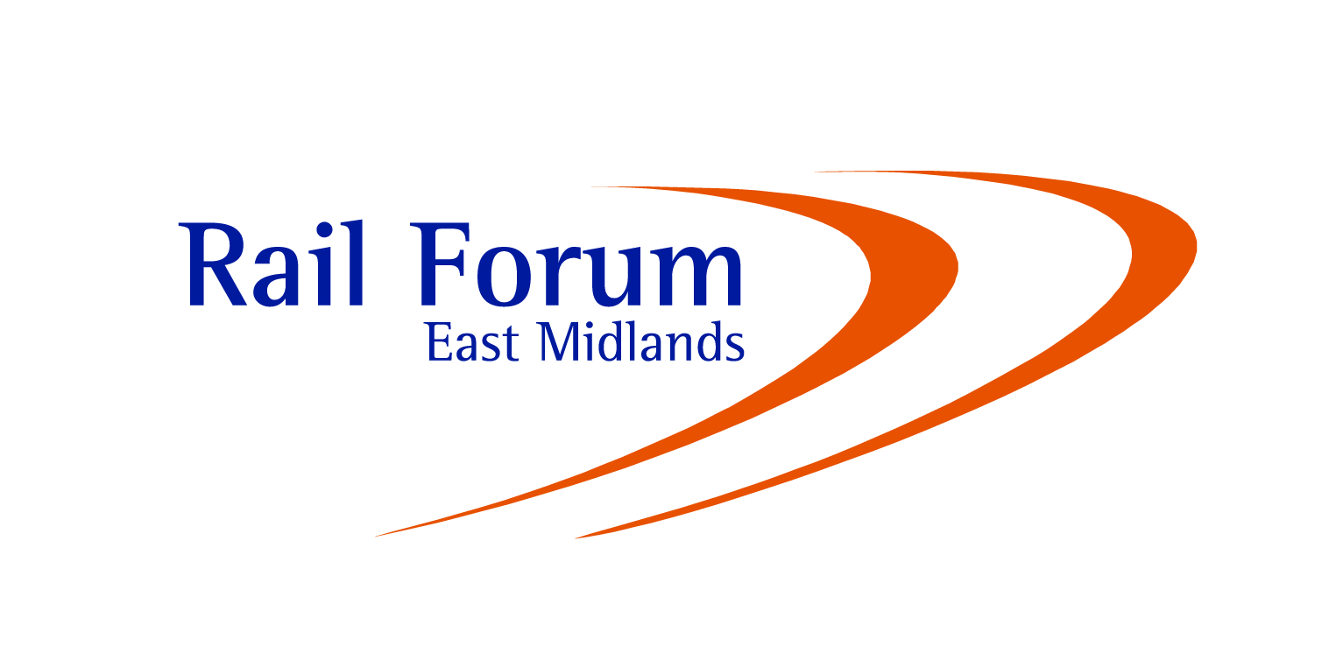
2016 Charity Golf Day
Breadsall Priory Golf & Country Club
Friday 23 September 2016
This year’s annual golf tournament will be held again at Breadsall Priory Golf & Country Club, Moor Road, Morley, DE7 6DL on 23 September 2016.

Teams of 4 from Forum members, rail businesses, both men and ladies, are invited to compete for the Neil Harvey Claret Jug, on this spectacular Derbyshire course. All proceeds from the event will be donated to charities.

We hope that you will be able to support our event and enjoy an excellent day of golf in good company, and beautiful surroundings.

Competition Details:
Starting times: From 9.40 a.m.
Format: 4 Ball Better Ball
Best 2 Scores to count on each hole, with all 4 scoring on 18th
3/4 Handicap Allowance
Teams of either Men, Ladies or Mixed
Dinner: On completion of the round at 5.30 followed by Prize Giving

Prizes: 1st, 2nd and 3rd Team Prizes
plus Nearest the Pin and Longest Drive
Cost: £300.00 plus VAT per Team – including meal (invoices will be issued)
………………………………………………………………………………………………………………………ENTRY FORM - Closing Date: Friday 19 September 2016

2016 Rail Forum Charity Golf Tournament

TEAM NAME:
NAME HANDICAP
1.
2.
3.
4.
Please return to Sue Dean, Rail Forum East Midlands, Lonsdale House, Quaker Way, Derby DE1 3HB or by e-mail to sue@midlandsrail.co.uk.

Please advise any special requirements (i.e. Starting Times, Vegetarian Meals, etc.)
_________________________________________________________________________________

_________________________________________________________________________________
Name: __________________________________________________________________________

Company: _____________________________________________________ Date: ____________

